TEAR OFF DEPARTMENT OF TRANSPORTATION SUPPLEMENTAL BEFORE USING FEDERAL AVIATION ADMINISTRATION INFORMATION
CERTIFICATION OF WAIVER OR AUTHORIZATION APPLICATION - PRIVACY ACT
The information on the accompanying form is solicited under authority of Federal Aviation Regulations Parts 91, 101, and 105.
Submission of the information is mandatory.
The purpose of this information is to establish eligibility for certificate of waiver or authorization
The data will be used for recordkeeping and statistical purposes.
Incomplete submission may result in delay or denial of your request.
FAA Form 7711-2 (8/08) Supersedes Previous Edition
DETACH THIS PART BEFORE USING
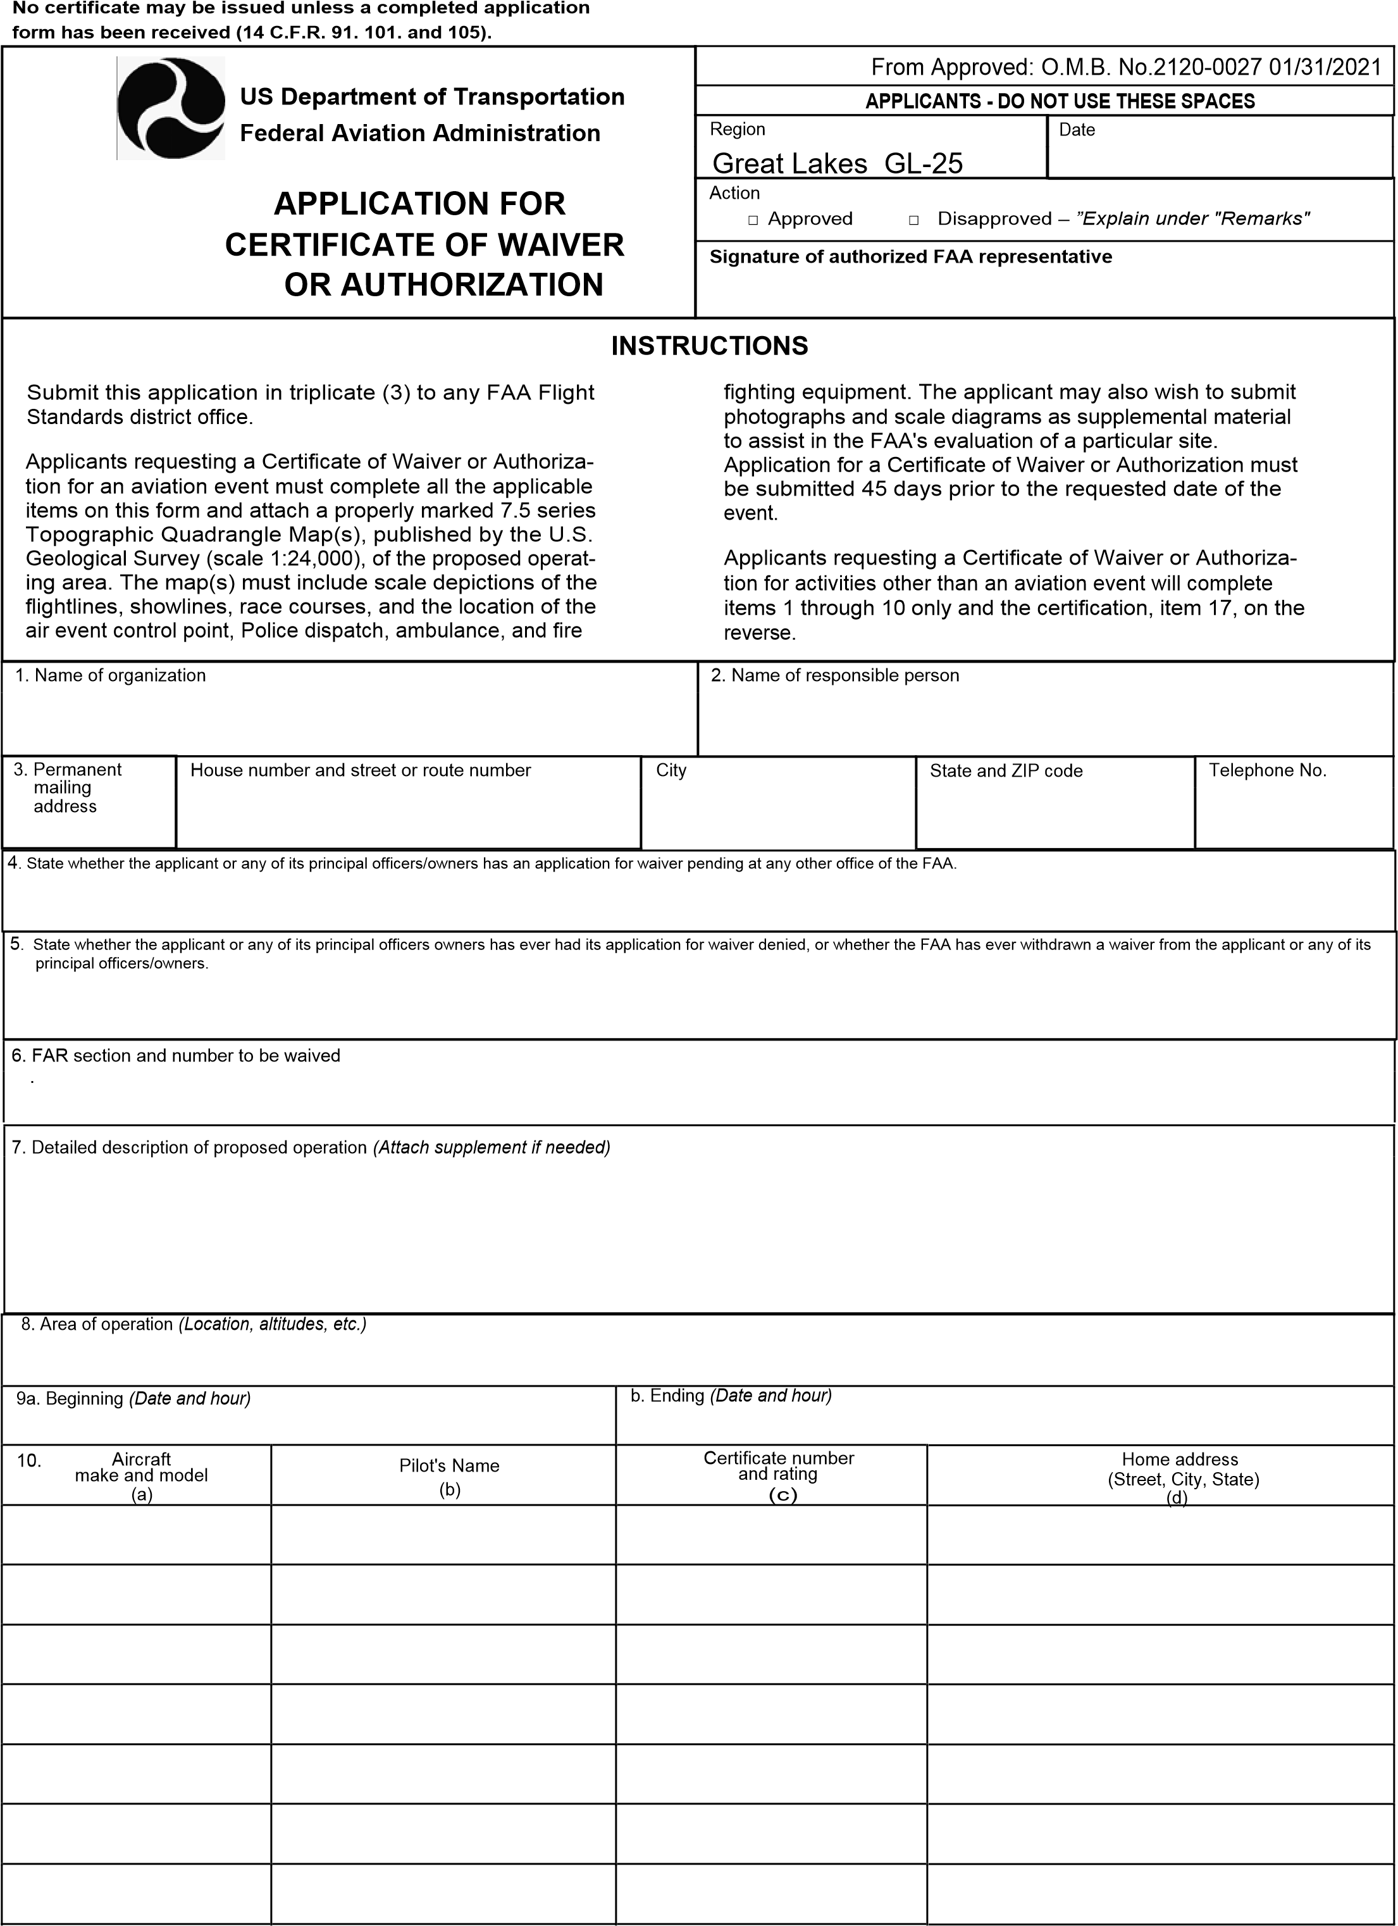FAA Form 7711 -2 (8/08) Supersedes Previous Edition Page 1
See Attachment
08/10/2025 09:30
08/08/2025 06:30
The primary launch field at Wadsworth Municipal A/P will be the center point of a 10 nautical mile radius flying area from the surface to 7000’ AGL
Hot Air Balloon Event with flight operations from surface up to 7,000 AGL occurring within a 10 nautical mile radius of the primary launch field as identified in the 2024 Balloon Operations Manual at coordinates 40 Deg 58’ 01”N 85 Deg 23’ 42”W (LAT/LOG) in Wadsworth, OH. Final landings may occur beyond this distance, however no goals/targets, pilot choice for take-offs or mass ascensions will exceed these boundaries.
14 CFR Part 91, 91.119 (b) and (c) Minimum Safe Altitudes
NO
NO
2602240251
IN, 46783
Roanoke
2921 E 950 N
Christopher T. Smart
Balloons Over Wadsworth
 | ITEMS 11 THROUGH 16 TO BE FILLED OUT FOR AIR SHOW/AIR RACE WAIVER REQUESTS ONLY.
11. The air event will be sponsored by:
Inspire Aviation
12. Permanent mailing address |  |  | House number and street or route number  840 Airport Drive |  |  | City  Wadsworth | State and ZIP code | Telephone No.  3303351257  OH 44281
13. Policing (Describe provisions to be made for policing the event.)
The 2025 Balloon Operations Manual will provide provisions of crowd and traffic control which will be performed by the event officials or local law enforcement, as appropriate, in the area of operations and at all goals/targets.
14. Emergency facilities (Mark all that will be available at time and place of air event.)
□ Physician □ Fire truck □ Other - Specify
□ Ambulance □ Crash wagon
15. Air Traffic control (Describe method of controlling traffic, including provision for arrival and departure of scheduled aircraft.)
A NOTAM will be required and placed by Lockhead Martin advising traffic of numerous balloons in the area at varying altitudes from Friday August 8 through August 10, 2025; during the 3 hours after sunrise and 3 hours before sunset. The event safety officer will be in contact with 3G3 personnel before each scheduled flight. Details of the flight and anticipated flight plan, including altitudes will be discussed at that time.
16. Schedule of Events (include arrival and departure of scheduled aircraft and other periods the airport maybe open.)
Hour  (a) |  | Date  (b) |  |  | Event  (c)  Hot Air Balloon Activity
06:32 – 09:30  19:00 – 09:33  06:31 – 09:30  19:00 – 20:34  06:30 – 09:30 |  | Aug 10, 2025  Aug 9, 2025  Aug 8, 2025 |  |  | Hot Air Balloon Activity  Hot Air Balloon Activity  Hot Air Balloon Activity
If sufficient space is not available, the entire schedule of events may be submitted on separate sheets, in the order and manner indicated above.
The undersigned applicant accepts full responsibility for the strict observance of the terms of the Certificate
Please Read of Waiver or Authorization, and understands that the authorization contained in such certificate will be strictly limited to the above described operation.
17. Certification - I CERTIFY that the foregoing statements are true.
Date  04/20/2025 |  |  |  | Signature of Applicant
Remarks
April 20, 2025
Christopher T. Smart Commercial Pilot Certificate 3131276
FAA Form 7711-2 (8/08) Supersedes Previous Edition Page 2

